Assessment Schedule – 2011
Physics: Demonstrate understanding of aspects of wave behaviour (90938)
Evidence Statement
Q | Achievement | Merit | Excellence
ONE  (a) | Refraction at either boundary is correct.  Or no normal/arrows | 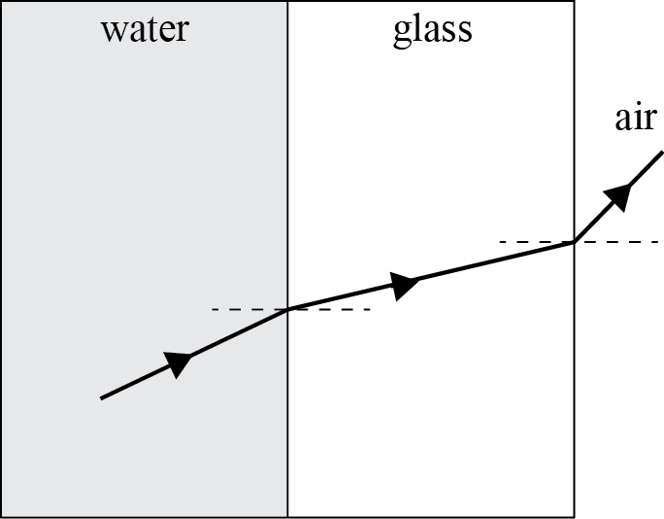  Refraction at both boundaries is correct.
(b) | Refraction takes place because light travels at different speeds in different media.  OR  Refraction takes place because light travels through media of different densities.  OR  One boundary specifically described. | Refraction takes place because light travels slower in glass than water so bends towards the normal, and faster in air than glass so bends away from the normal..  OR  Refraction takes place because light travels from less dense water to more dense glass and bends towards normal. Light travels from more dense water to less dense air and bends away from normal.
(c) | Angle incidence > critical angle.  OR  Reflects back the light because of total internal reflection. | Angle incidence > critical angle, total internal reflection at both surfaces..
(d)
  yellow
  green
  violet
(e) | Generalised statement that the speed / different frequencies / wavelengths / different refractive indices as the cause of bending.  OR  Specifics for ONE colour | Blue has shorter λ / higher frequency so bends more when entering prism.  AND  Red light has longer λ / lower frequency do bends less when enters prism. | (1) The speed of the blue light in the prism is slower than the speed of red light. This causes the blue light to bend more than red light.  OR  (2) Glass has a higher refractive index for blue light, it travels slower than red and so it bends more.

Scoring Rubric
N0 | N1 | N2 | A3 | A4 | M5 | M6 | E7 | E8
No correct relevant physics. | 1A | 2A  OR  1M | 3 A  OR  1A 1M | 4 A  OR  2A 1M | 2M | 3M | (e) answer 1 | (e) answer 2

Q | Achievement | Merit | Excellence
TWO  (a)(i)  (ii) | Any TWO of:  • object distance is equal to image distance  • same size as the object  • upright  • virtual  OR   | Any TWO of:  • object distance is equal to image distance  • same size as the object  • upright  • virtual  AND
(b)(i)  (i) (ii) | A: Reflection is regular.  B: Reflection is irregular or diffused.  OR  Reflected rays are parallel in A while in B reflected rays are not parallel / scattered / diverge / disperse.  OR  Surface A produces a clear image, while surface B produces a blurred image.  OR  Surface A is smooth so they reflect evenly while surface B is uneven / rough so they reflect unevenly. | A: Reflection is regular.  B: Reflection is irregular or diffused.  OR  Reflected rays are parallel in A while in B reflected rays are not parallel.  OR  Surface A produces a clear image, while surface B produces a blurred image.  AND  Angle incidence = angle reflection so surface A smooth gives parallel but surface B uneven, so incident rays hitting at different angles.
(c) | Reflection of the opposite / both walls by the mirrors makes the room look bigger.  NOT reflecting each other. | Each mirror reflects the opposite wall / room. The person sees the image of the respective walls behind the mirrors. This creates a feeling of space / depth.
(d) | The image or a ray is drawn correctly.  OR  Good construction lines (normal and dotted line) but no image or arrows. | Image size and position are correct with a correctly drawn reflected ray. No arrows to show the direction of light or the image seeking ray is not dotted.  Accept ONE or TWO rays. | Correctly drawn ray diagram with arrows for reflected rays and broken line for image seeking ray. Image size and position are correct. Accept ONE or TWO rays.  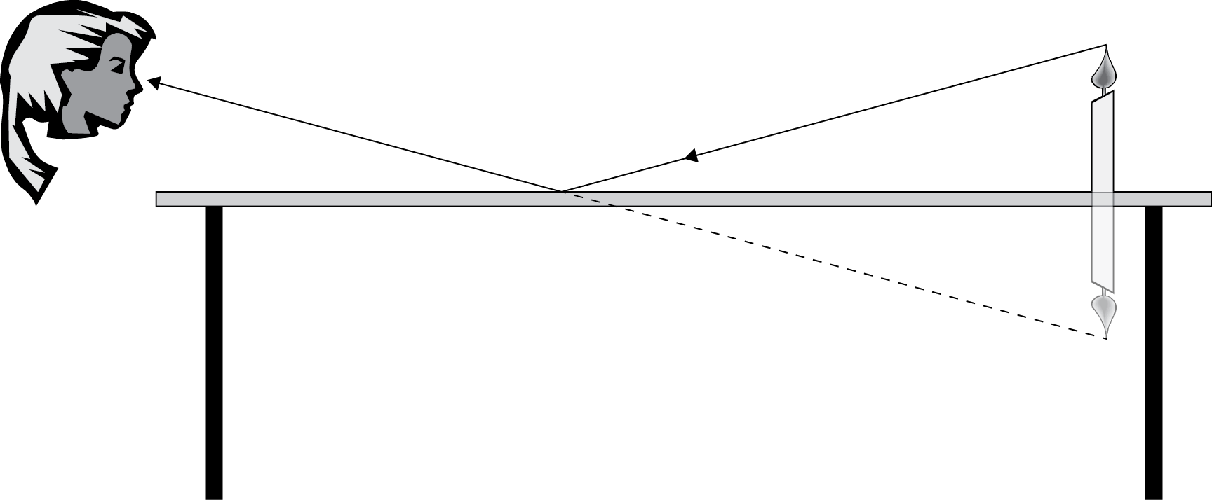

Scoring Rubric
N0 | N1 | N2 | A3 | A4 | M5 | M6 | E7 | E8
No correct relevant physics. | Partially correct A | 1A | 2 A  OR  1M | 3 A  OR  1A 1M | 2M | 3M | (d) answer no normal | (d) answer with normal

Q | Achievement | Merit | Excellence
THREE  (a) | Compression happens when particles / waves are forced / pressed / move, together.  OR  Rarefaction occurs when particles / waves are given extra space and allowed to spread out. | Compression happens when particles are forced/ pressed/move together / compression takes place when the pressure is higher.  AND  Rarefaction occurs when particles move apart / rarefaction takes place when pressure is lower.
(b) | 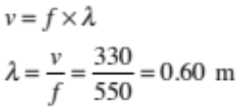 | 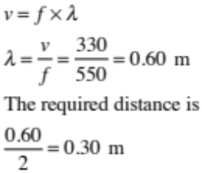
(c) | The distance between a compression and the next rarefaction will decrease. | When the frequency is increased, the wavelength will decrease. So the required distance will decrease. | The distance between a compression and the next rarefaction will decrease.  This is because:  • The velocity of sound in air remains constant.  • Since v = f × λ, when the frequency is increased, the wavelength will decrease. So the required distance will decrease  OR  As the frequency increases, the number of waves in a given space increases. This reduces the wavelength and hence the distance between a compression and the next rarefaction.  velocity the same.
(d) | 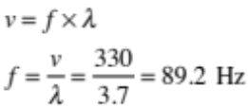 | 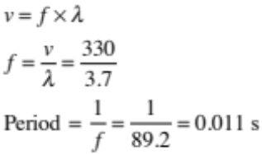

Scoring Rubric
N0 | N1 | N2 | A3 | A4 | M5 | M6 | E7 | E8
No correct relevant physics. | Partially correct A | 1A | 2 A  OR  1M | 3 A  OR  1A 1M | 2M | 3M | The answer implies the correct idea but not clearly expressed  One of equation or speed missing | Answer is clear and precise.  Uses  v = f × λ,

Q | Achievement | Merit | Excellence
FOUR  (a) | Diffraction.
(b) | Correct shape.  OR  Diagram shows no change in wavelength, but reasonably similar pattern.  OR  Too much diffraction (touching edges). | 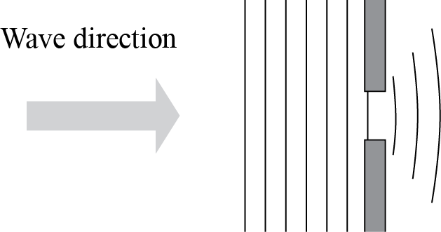  The diagram shows the correct shape with no change in wavelength.
(c) | The shape of the diffracted wave will be more circular.  OR  The wavelength remains the same. | The shape of the diffracted wave will be more circular and the wavelength remains the same.  OR  These ideas are indicated in a diagram.
(d) | The distance between the first and the last floats  = 5 × 9 = 45 m  OR one correct calculation  Eg v with wrong d. | The distance between the first and the last floats  = 5 × 9 = 45 m  Time taken to travel 45 m  = 1 min × 60 = 60 s  Speed of the waves is  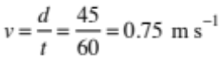  OR  TWO correct calculations. | The distance between the first and the last floats  = 5 × 9 = 45 m  Time taken to travel 45 m  = 1 min × 60 = 60 s.  Speed of the waves is  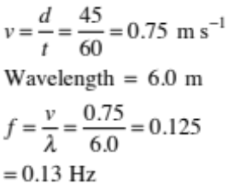

Scoring Rubric
N0 | N1 | N2 | A3 | A4 | M5 | M6 | E7 | E8
No correct relevant physics. | Partially correct A | 1A | 2 A  OR  1M | 3 A  OR  1A 1M | 2M | 2M  one must be (d) | Used t as 1.0 min and got an answer of 7.5 Hz | All of (c) is correct.  Unit correct

Judgement Statement
 | Not Achieved | Achievement | Achievement  with Merit | Achievement  with Excellence
Score range | 0 – 11 | 12 – 19 | 20 – 26 | 27 – 32

